Applying for an ETA
The application process is completely online, through either the UK ETA app or GOV.UK website. You’ll be asked to:
- Confirm your identity (See the below section)
- Answer some questions about yourself
- Pay the £16 application fee
Be aware of fraudulent apps and websites. Download the app or fill out the online form directly from the GOV.UK.
Before you start the application, you’ll need:
- Your passport
- Access to your email
- A debit / credit card

Confirming your identity
You’ll be asked to confirm your identity by first taking a photo of your passport and confirming your passport details.
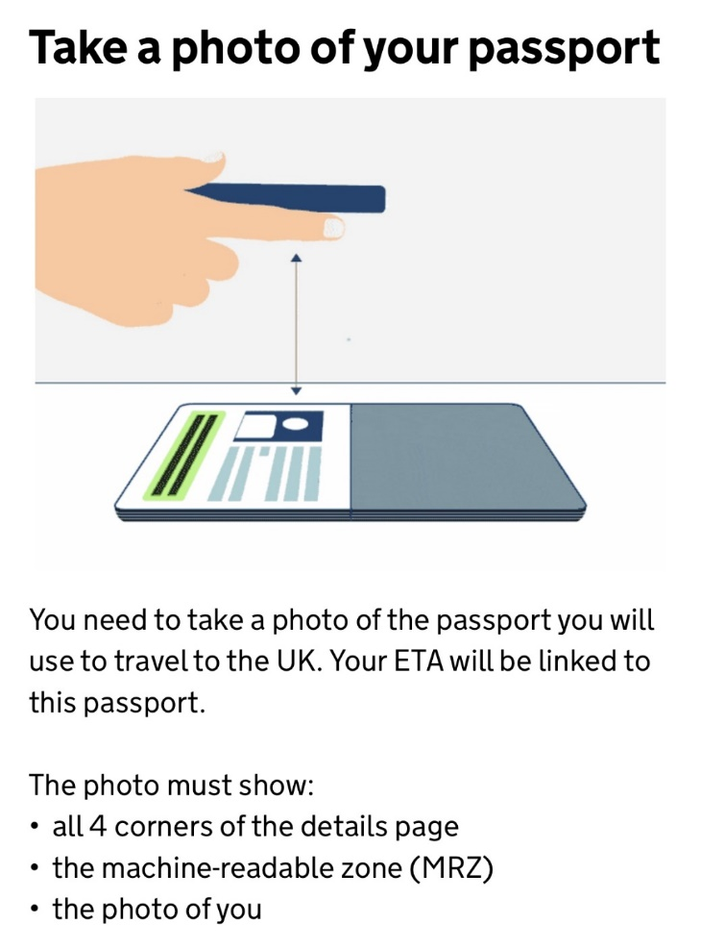

Then, you’ll be asked to scan and provide a photo of your face.
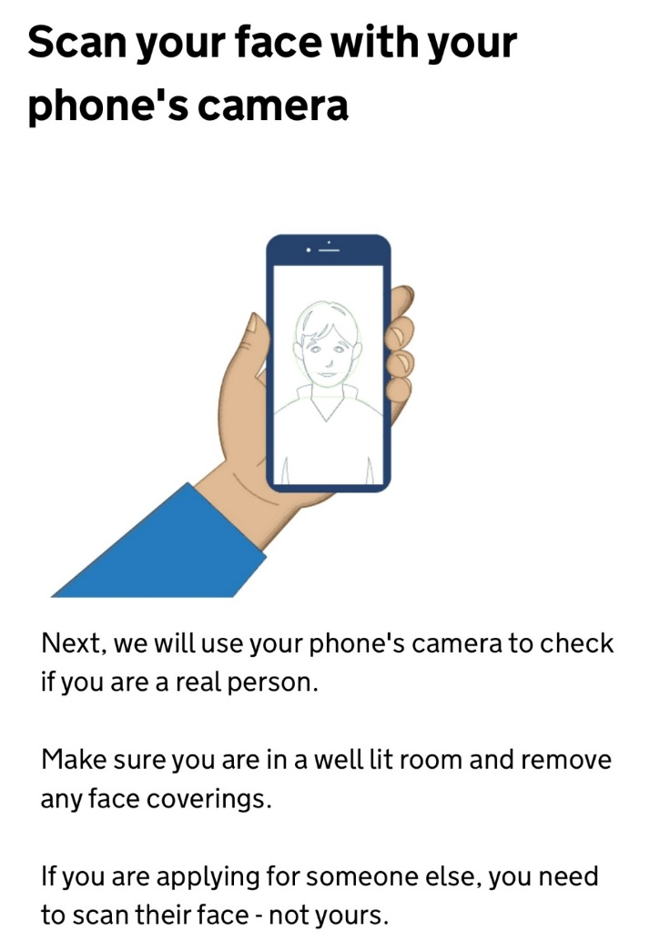 | 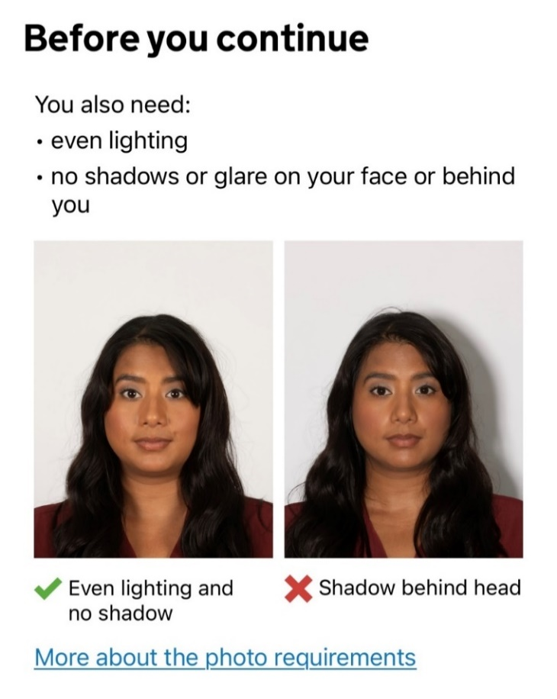

Tips for applying an ETA:
- Use the UK ETA app if you can.
- Use the passport that you will use for your travel.
  - If you are in the process of renewing your passport or plan to, wait until you receive your new passport before applying; or
  - If you hold more than one passports because you have more than one nationalities, use the one you’ll use to book your ticket and bring it with you when you travel.
  - An ETA is linked to only one passport. If after receiving your ETA, you have a new passport / decide to travel with a passport from another country, you’ll need to apply for an ETA again with that passport.
- You can take multiple tries at taking the photos of your passport and your face.
- Do not hit “Continue” until you are confident that you have met all the requirements for the photos. Your application could be delayed or even rejected if your identity cannot be established.

ETA decisions and travel to the UK
You should receive an email from UKVI confirming the decision of your ETA application within three working days after submitting.
While the email itself is not your ETA and carriers and Border Force should see from their systems that you have an ETA with just your passport, you are recommended to have a print-out of the email in your hand luggage just in case of any issues.
When your ETA is granted, it will remain valid for 2 years or until your passport expires (whichever is sooner). This does not mean you can stay in the UK for 2 consecutive years. You must still leave the UK within 6 months of you entering the country. What it means is that you can make multiple up-to-6-month journeys to the UK while your ETA is unexpired.
If your ETA is rejected, you will be told the reason and will need to apply again.
If your ETA is refused, you will need to apply for a Visitor visa instead before you can come to the UK. You can contact the university’s Advice and Counselling Service for advice when that happens or if you have any questions with the ETA application.

Please note immigration rules and fees are subject to change. It is your responsibility to ensure you have the up-to-date information before applying. When in doubt, please contact Advice and Counselling Service.

